3/31/2026
LAB NO 07
COAL
Submitted to: SIR IMRAN

Submitted by: WASIF ALI
245187
BSCS’F24 4-B

Task 01:
Code:
INCLUDE Irvine32.inc

.data
vals BYTE 1, 3, 5, 7, 9

.code
main PROC

mov esi, 0 ; start index
mov edi, 4 ; end index

L1:
mov al, vals[esi]
xchg al, vals[edi]
mov vals[esi], al

inc esi
dec edi

cmp esi, edi
jl L1

; (Optional) display result
mov ecx, LENGTHOF vals
mov esi, OFFSET vals

printLoop:
movzx eax, BYTE PTR [esi]
call WriteInt
call Crlf
inc esi
loop printLoop

exit
main ENDP

END main
Output:
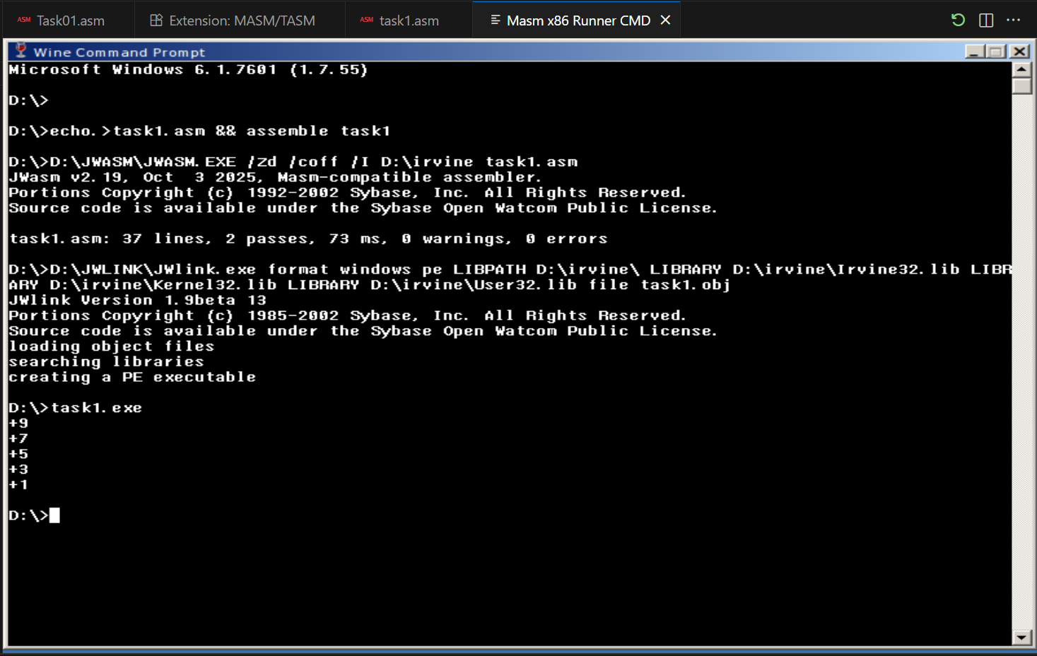

Task 02
Code:
INCLUDE Irvine32.inc

.data
vals BYTE 1,3,5,7,9
sum DWORD 0

.code
main PROC

mov ecx, LENGTHOF vals ; loop counter
mov esi, OFFSET vals
mov eax, 0 ; accumulator

L1:
movzx ebx, BYTE PTR [esi] ; load byte → extend to 32-bit
add eax, ebx
inc esi
loop L1

mov sum, eax

; display result
call WriteInt
call Crlf

exit
main ENDP
END main

Output:
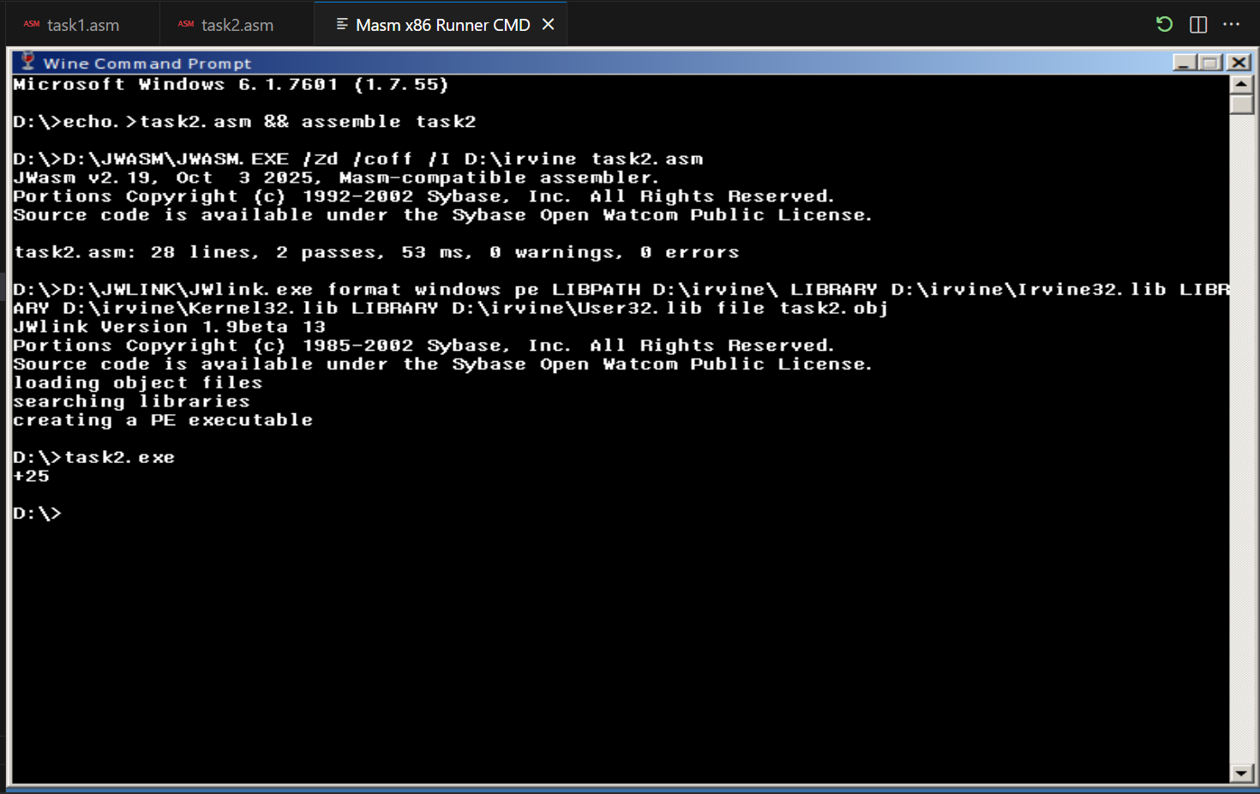

Task 03
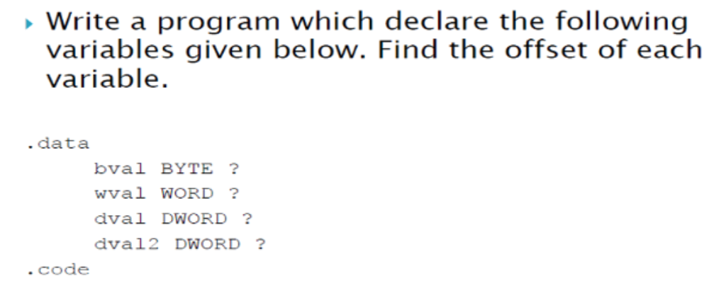

Code
INCLUDE Irvine32.inc

.data
bval BYTE ?
wval WORD ?
dval DWORD ?
dval2 DWORD ?

.code
main PROC

mov eax, OFFSET bval
call WriteInt
call Crlf

mov eax, OFFSET wval
call WriteInt
call Crlf

mov eax, OFFSET dval
call WriteInt
call Crlf

mov eax, OFFSET dval2
call WriteInt
call Crlf

exit
main ENDP
END main

Output:
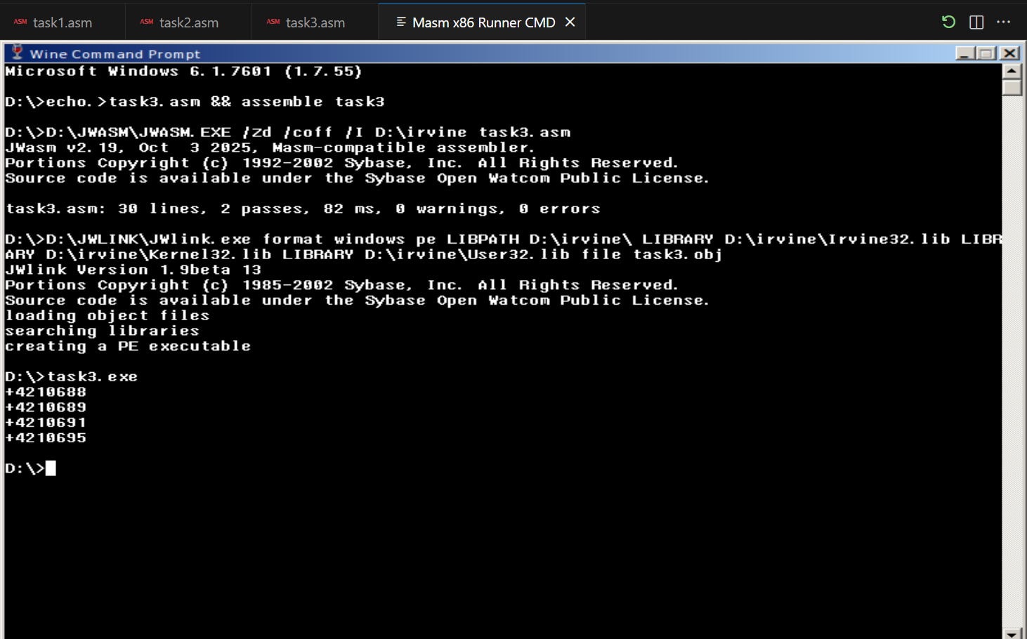

Task 04
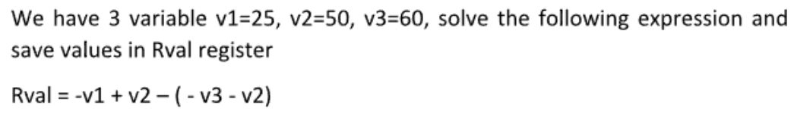

Code
INCLUDE Irvine32.inc

.data
v1 DWORD 25
v2 DWORD 50
v3 DWORD 60
Rval DWORD ?

.code
main PROC

mov eax, v1
neg eax ; -v1

add eax, v2 ; -v1 + v2

mov ebx, v3
neg ebx ; -v3
sub ebx, v2 ; -v3 - v2

sub eax, ebx ; subtract

mov Rval, eax

; display result
call WriteInt
call Crlf

exit
main ENDP
END main

Output
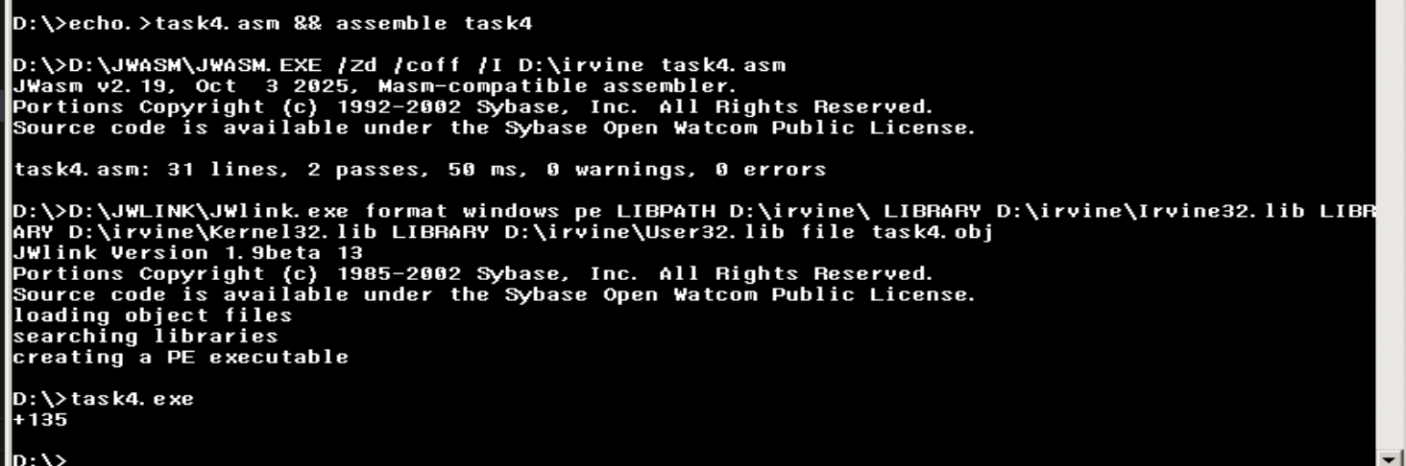

Task 05:
Code:
INCLUDE Irvine32.inc

.code
main PROC

mov al, 0FFh
inc al ; AL = 00h → ZF=1, OF=0

call DumpRegs ; show registers & flags

mov bl, 00h
dec bl ; BL = FFh → SF=1

call DumpRegs

exit
main ENDP
END main

Output:
